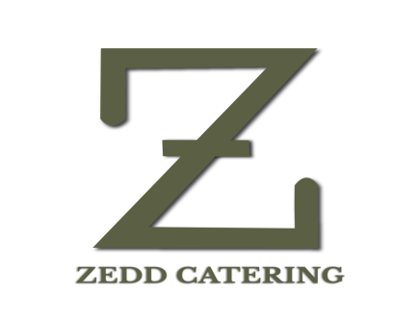

**DINNER**

**MOCKTAIL COUNTER**

**BLUE HAWAIIAN**

**KIWI BASIL MOJITO**

**GUAVA DELIGHT**

**LYCHEE MADNESS**

**HOT BEVERAGE**

**Tea and coffee**

Masala Tea

Green tea

Assam Tea

Darjeeling Tea

Readymade Coffee

Black coffee

Cookies & biscuit

**Starter**

**Paneer tikka laal mirch**

**Cheese Ball**

**Spring Roll**

**Ajwani Fish Tikka**

**Bengali Fish fry**

**Tangra Style chilli Chicken**

**SOUP**

**Cream of chicken soup**

**Tomato soup**

**ACOMPANIMENTS**

**Buns, bread sticks & butter**

**SALAD**

**Garden Fresh Salad**

**Russian Salad**

**Macaroni & sundried salad in Thousand Island dressing**

**Aloo Papdi Chaat**

**Assorted Papad (Roasted & Fried)**

**Pickle**

**CURD ITEAMS**

**Mixed vegetable raita & Dahi Bhalla**

**CHUTNEY, PICKLE & PAPAD**

**Roasted Papad**

**Fried Papad**

**Bat Papad**

**Pudina chutney**

**khejur Amsotto Chutney**

**Achar- 3 Types**

**MAIN COURSE**

**Sultani Panner**

**Bhojpuri Aloo dum**

**Vegetable Sunheri Kofta**

**Kacha Lonka dhone pata bata murgi**

**Kalahari Mutton**

**Doi Katla**

**DAL**

**Dal Makhani**

**Sona Moong Dal/Moong Mohini**

**RICE**

**Vegetable Pulao**

**Basanti Pulao**

**Jeera rice**

**INDIAN BREADS**

**Tandoori Roti/ Fulka ,Butter Naan,Green peas Kachuri,Puran Puri**

**Live**

**Mongolian Counter**

**( Rice , Noodels, Three types of Sauce, Choices of vegetable like Choices of Vegetable like Broccoli, Mushroom, Corn, Zucchini, Carrot, Peas Etc).**

**DESSERT**

**Rasmalai**

**Misti Doi**

**Pantua**

**Vanilla Ice cream (Chocolate & Vanilla)**