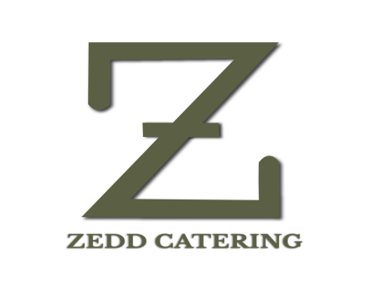

**DINNER**

**MOCKTAIL COUNTER**

**BLUE HAWAIIAN**

**KIWI BASIL MOJITO**

**GUAVA DELIGHT**

**HOT BEVERAGE**

**Tea and coffee**

Masala Tea

Green tea

Assam Tea

Darjeeling Tea

Readymade Coffee

Black coffee

Cookies & biscuit

**Starter**

**Paneer tikka laal mirch**

**Spring Roll**

**Ajwani Fish Tikka**

**Tangra Style chilli Chicken**

**SOUP**

**Cream of chicken soup**

**Tomato soup**

**ACOMPANIMENTS**

**Buns, bread sticks & butter**

**SALAD**

**Garden Fresh Salad**

**Russian Salad**

**Assorted Papad (Roasted & Fried)**

**Pickle**

**CURD ITEAMS**

**Mixed vegetable raita /Plan Curd**

**CHUTNEY, PICKLE & PAPAD**

**Roasted Papad**

**Fried Papad**

**Bat Papad**

**Pudina chutney**

**khejur Amsotto Chutney**

**Achar- 3 Types**

**MAIN COURSE**

**Paneer lababdar**

**Jodhpuri aloo dum**

**Malai kofta**

**Kacha Lonka dhone pata bata murgi**

**Doi Katla**

**DAL**

**Dal Makhani**

**Burnt Garlic Yellow Dal**

**RICE**

**Vegetable Pulao**

**Jeera rice**

**INDIAN BREADS**

**Tandoori Roti/ Fulka ,Butter Naan,Green peas Kachuri**

**DESSERT**

**Malai Chumchum**

**Hot Gulab Jamun**

**Vanilla Ice cream (Chocolate/Vanilla)**